3-Position Chaise Lounger

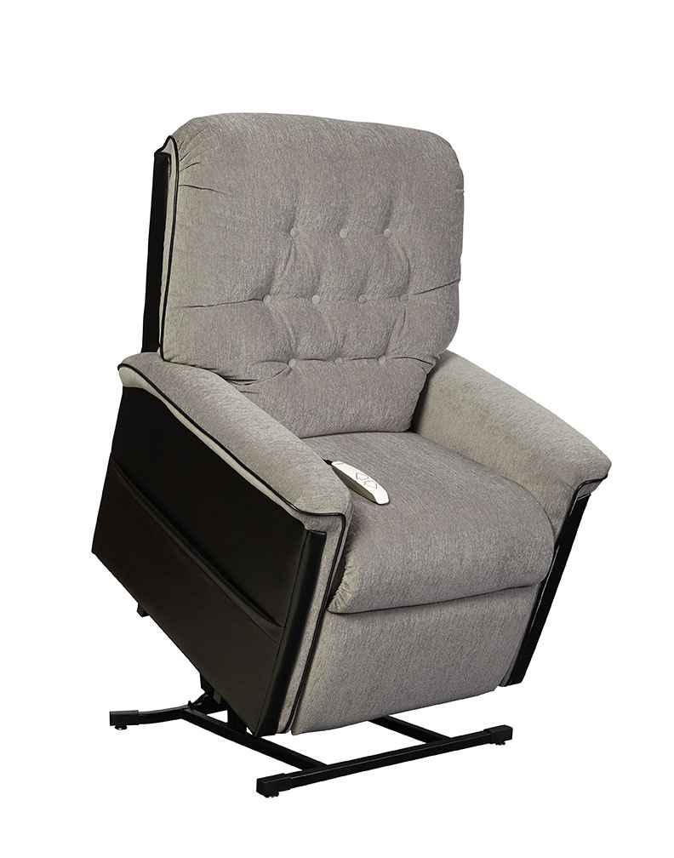
QUINN
Quinn
3-Position Reclining Lift Chair
Features and Benefits:
- Three-position, all electric lift and recline
- Furniture grade hardwood/plywood construction
- Heavy-duty steel lift mechanism
- 375 lb maximum weight capacity
- Integrated emergency battery backup
- 2-toned fabric offers a great Crypton fabric with vinyl accents
- Convenient pocket on both sides of chair to store magazines, newspapers, or a remote control
- Warranty: 1 year parts and service and lifetime on lift frame
Weight Capacity: 375 lbs
Seat to Floor Height: 20”
Seat Depth: 20”
Seat Width: 20”
Top of Back to Seat: 24.5”
Outside Arm Width: 35”
Top of Back to Floor: 42”
Overall Chair Weight: 117 lbs
Fabric Options:
Lexi/Aria Combination: Black/Cool Grey

Lexi/Aria Combination: New Chestnut/Sand

