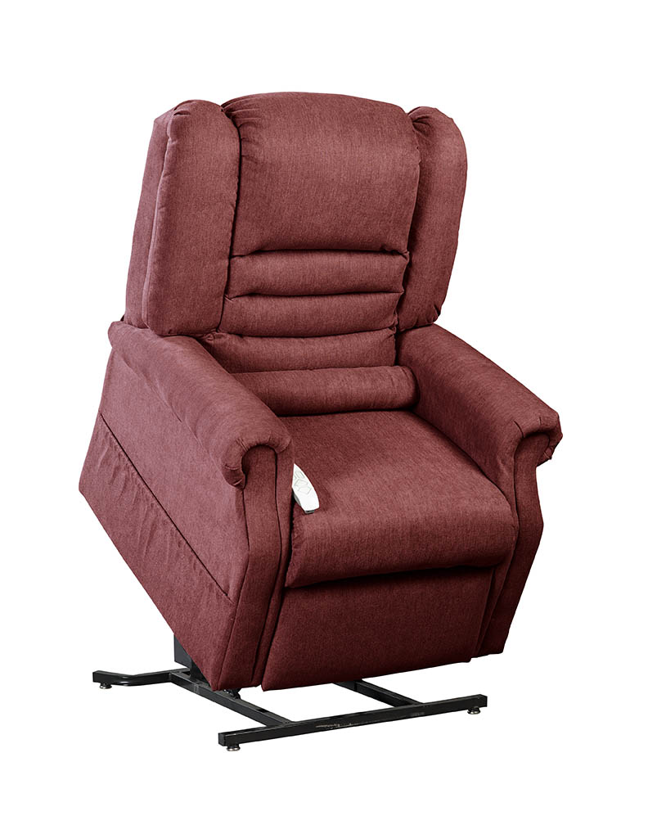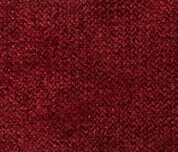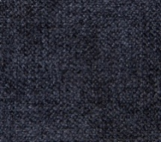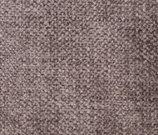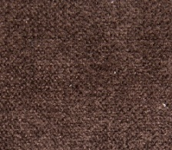

Note: Specifications subject to change without notice

**SPECIFICATIONS**

**Model:** NM-1850, Infinite position

**Weight Capacity**: 325 lbs

**Seat Width**: 21”

**Seat Depth**: 20”

**Top of Back to Seat**: 27”

**Top of Back to Floor**: 47”

**Outside Arm Width**: 33”

**Seat to Floor:** 20”

**FEATURES AND BENEFITS**

* Infinite position, all electric lift and recline
* Furniture grade hardwood/plywood construction
* Heavy duty steel lift mechanism
* Integrated emergency battery backup
* Comes standard with a bolster pillow for added comfort
* Convenient pocket on both sides of the chair to store magazines, newspapers or a remote control
* Chaise pad construction
* Designed to bring you superior comfort and support
* Warranty: One year on parts and service; limited lifetime on steel lift frame

Chocolate Dove Navy Burgundy

**Fabric Options: Felix**

NM1850-MEGACAT-080116

**NM-1850 Infinite Position Chaise Lounger**

Whether you want to sit back and relax, watch television or take a nap, you’ll love being able to ease into your Windermere Motion Power/Recline Lift Chair. This collection offers superb comfort and quiet and smooth performance, all with the push of a button. If you or a loved one needs assistance sitting down or standing back up, Windermere Motion Power/Recline Lift Chairs are the perfect choice to regain mobility and confidence.