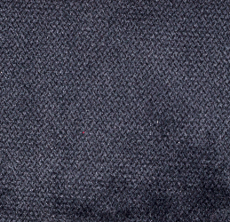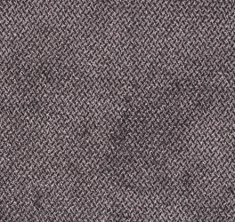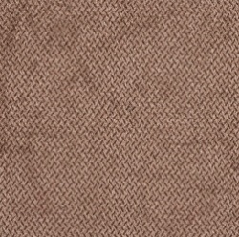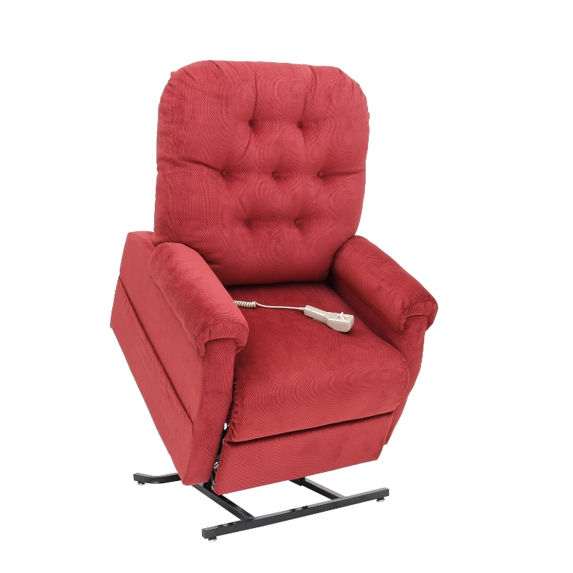

Camel Charcoal Navy Chocolate

(Image coming soon)

**Fabric Options: Otto**

Note: Specifications subject to change without notice

**SPECIFICATIONS**

**Model:** MM-200, Three Position

**Weight Capacity**: 325 lbs

**Seat Width**: 19”

**Seat Depth**: 19”

**Seat to Floor:** 19”

**Overall Chair Height:** 42.5”

**Overall Chair Width:** 33”

**Not shown in correct fabric. New image coming soon**

**FEATURES AND BENEFITS**

* Three position, all electric lift and recline
* Furniture grade hardwood/plywood construction
* Heavy duty steel lift mechanism
* Integrated emergency battery backup
* Convenient pocket on both sides of the chair to store magazines, newspapers or a remote control
* Chaise pad construction
* Designed to bring you superior comfort and support
* Classic button back design
* Warranty: One year on parts and service; limited lifetime on steel lift frame

MM200-MEGACAT-111416

**MM-200 Three Position Chaise Lounger**

Whether you want to sit back and relax, watch television or take a nap, you’ll love being able to ease into your Windermere Motion Power/Recline Lift Chair. This collection offers superb comfort and quiet and smooth performance, all with the push of a button. If you or a loved one needs assistance sitting down or standing back up, Windermere Motion Power/Recline Lift Chairs are the perfect choice to regain mobility and confidence.