Three-Position Chaise Lounger
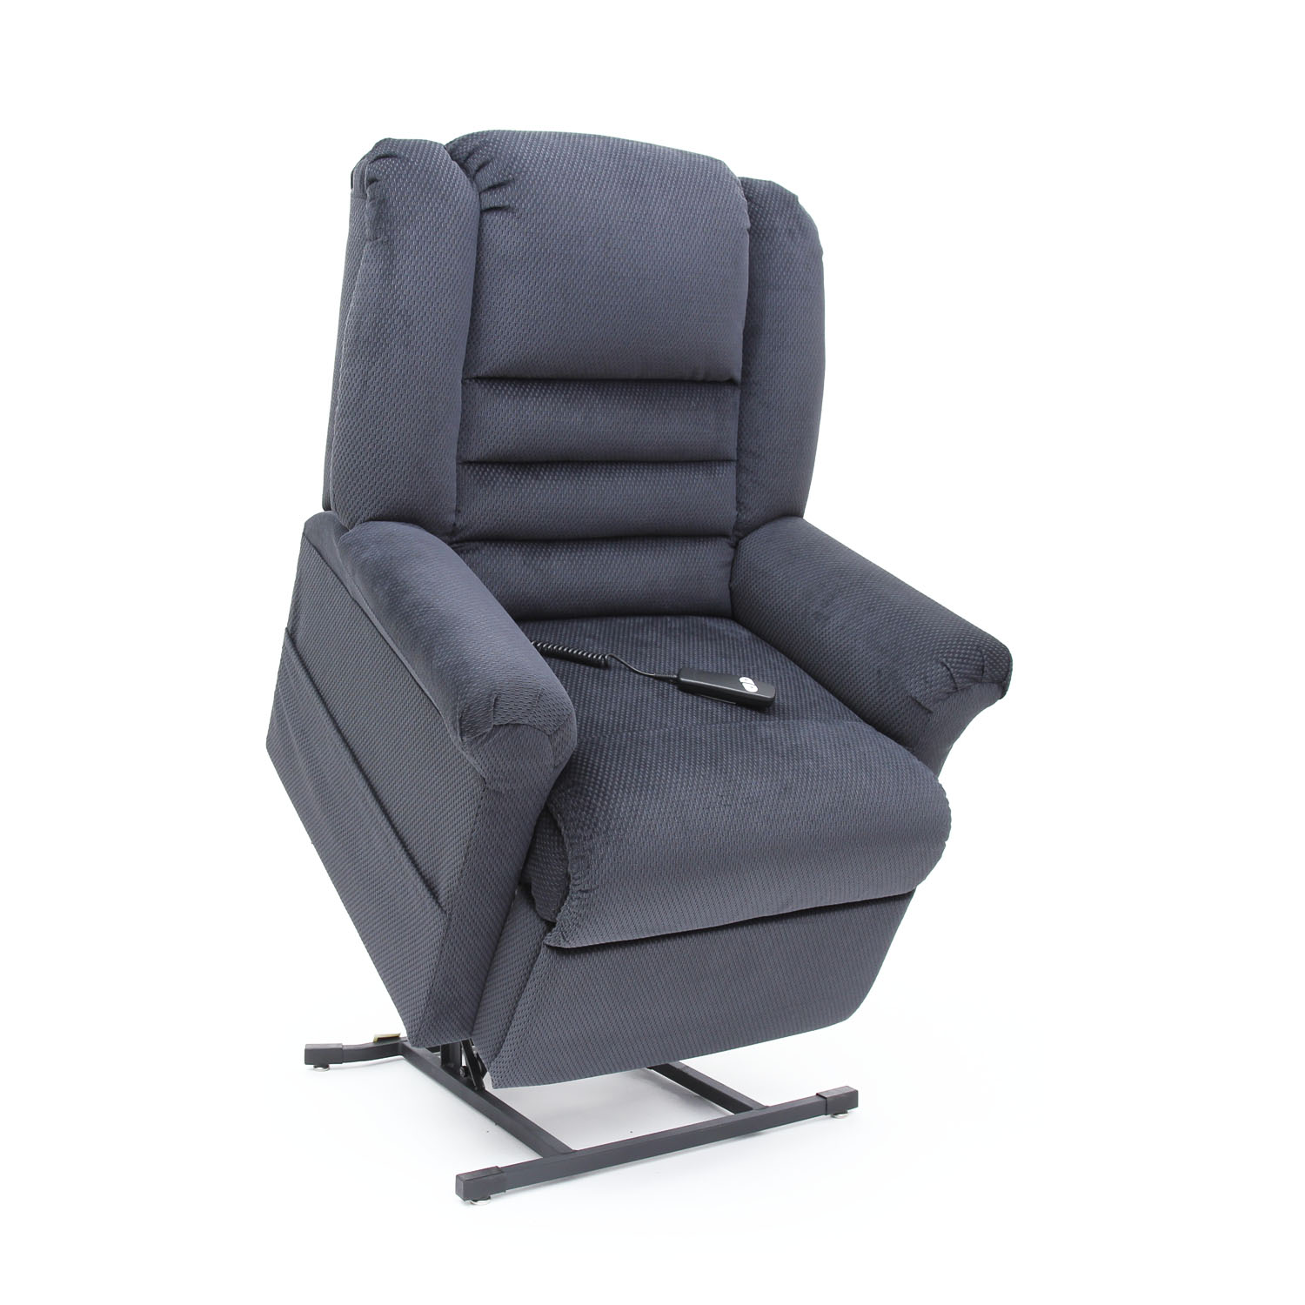
LC-400

LC-400 FEATURES AND BENEFITS
3-Position Chaise Lounger with Contour Pillow Back Design
- Three-position, all electric lift and recline
- Furniture grade hardwood/plywood construction
- Heavy-duty steel lift mechanism
- 375 lb weight capacity
- Chaise pad
- Heat and massage option available on Brown Sugar and Java fabric only
- Integrated emergency battery backup
- Warranty: 2 years parts, 1 year service, and lifetime on lift frame

Weight Capacity: 375 lbs
Overall Width: 34”
Overall Depth: 27.5”
Overall Height: 42.5”
Seat to Floor: 20”
Seat Width: 20”
Seat Depth: 20”
Top of Back to Seat: 27”

Model LC-400 Fabric Choices
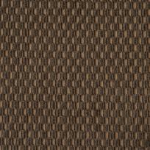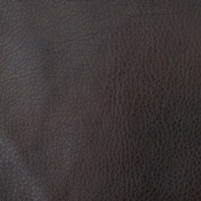
Brown Sugar Cordovan Evergreen Java Old Navy Burgundy Vinyl

