January 2, 2014

Memo

To: Mega Motion Accounts

From: Dennis Valkanoff

Re: January Inventory Blowout

Dear Mega Motion Accounts:

As we enter 2014 we have had an exceptional year of growth and we thank you. We have a number of chairs and scooters and we are phasing them out or have dropped the chairs and would like to offer them to you.

Simple rules:

- First Come-First Serve on Chairs-We will notify you weekly of the inventory status.
- Chairs are priced to deliver to the customer’s front door, one at a time.
- We are not placing any MAP on these products.
- If you need any materials to put on the web, please let us know.

Chairs Available
The following power recline/lift chairs are available in the colors set forth below:

Chair Fabric/Color Cost
LC 325 Black Vinyl $375
LC 400 Majestic/Java $420
LC 400 Majestic/Evergreen $420
LC 400 Majestic/Cordovan $420
LC 400 Majestic/Old Navy $420
LC 500 Java $525
LC 500 Evergreen $525
LC 500 Old Navy $525
LC 500 Vino $525
FC 503 Beluga $450
FC 503 Camel $450

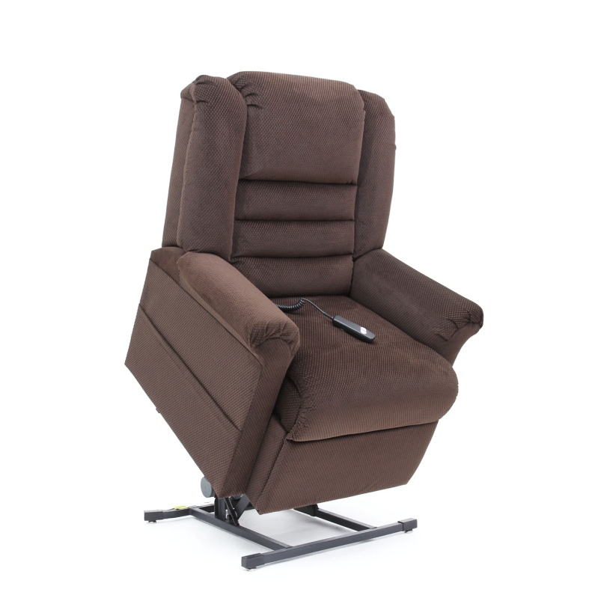
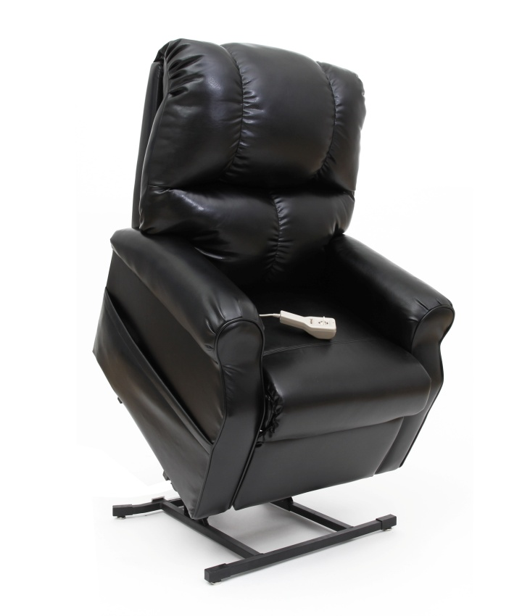

LC-325 BLACK VINYL LC-400 JAVA
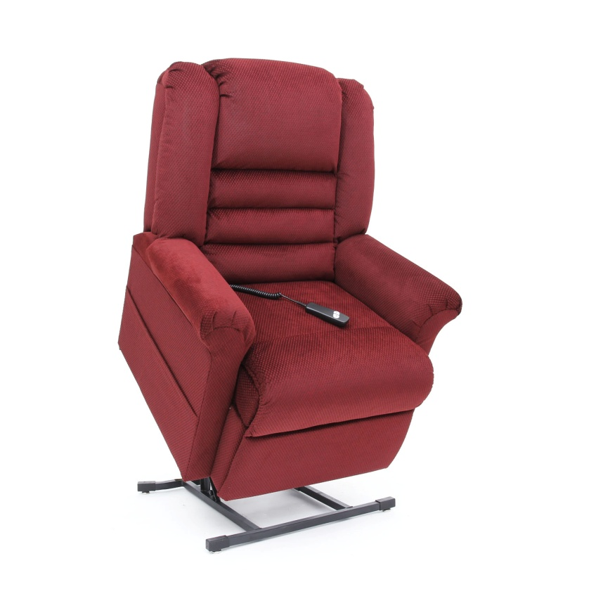
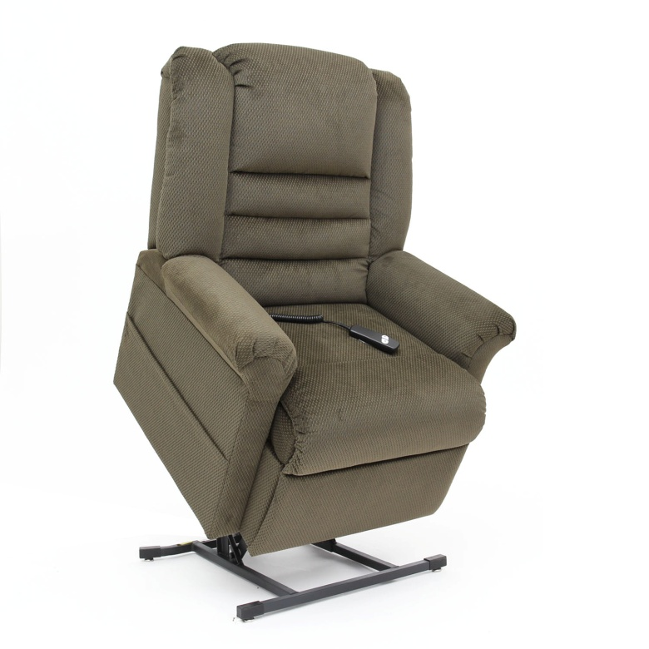

LC-400 EVERGREEN LC-400 CORDOVAN

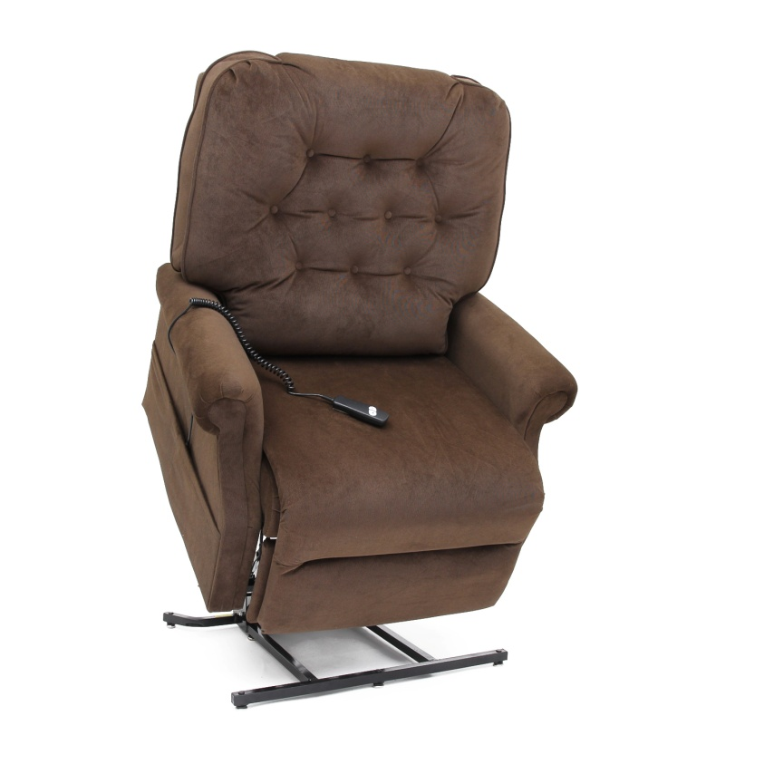
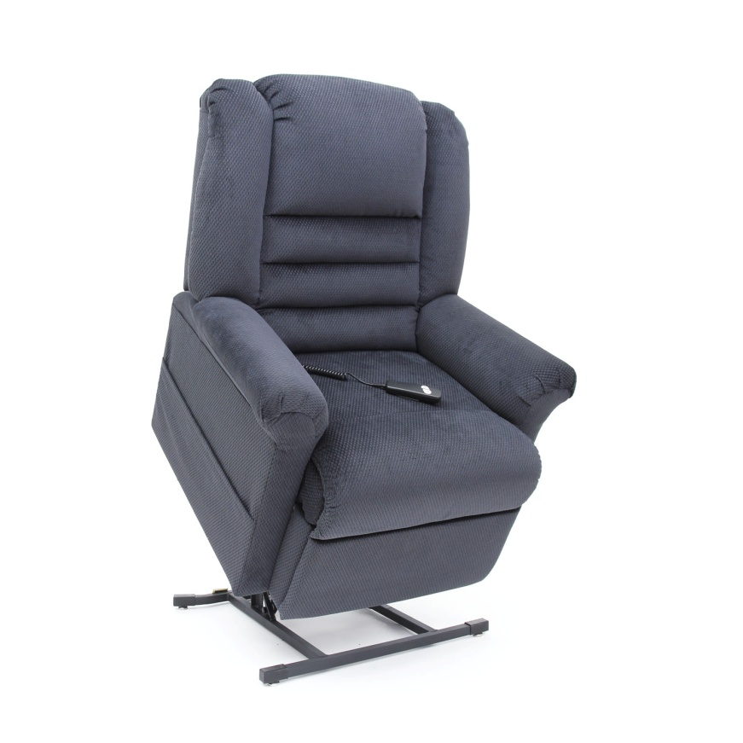

LC-400 OLD NAVY LC-500 JAVA

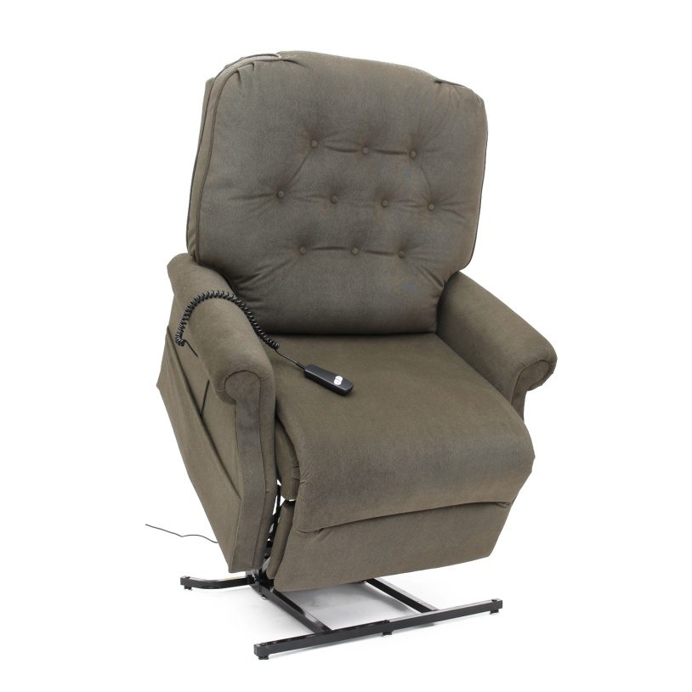
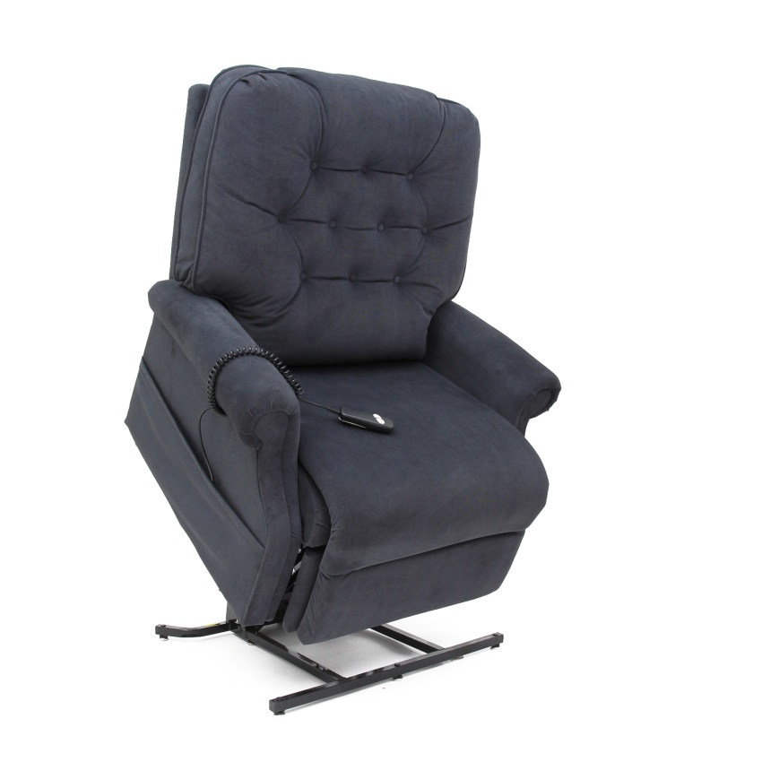

LC-500 EVERGREEN LC-500 OLD NAVY

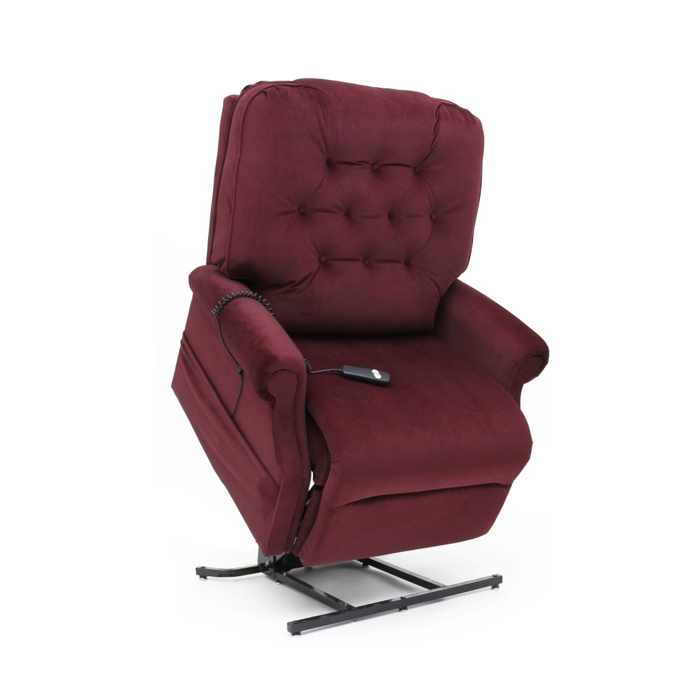
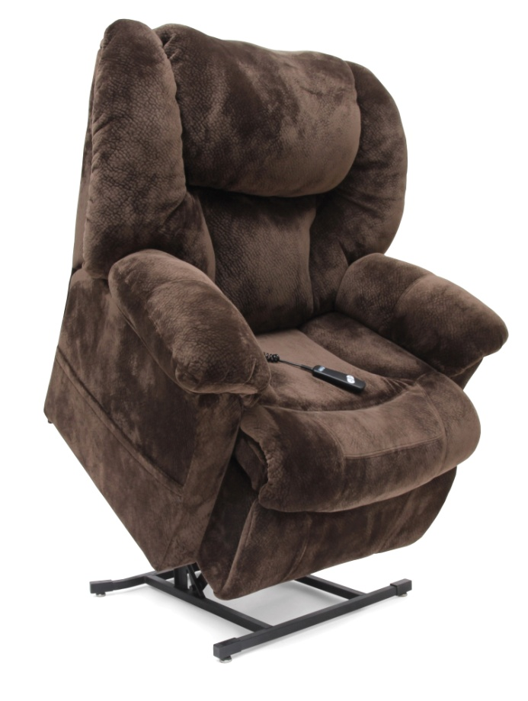

LC-500 VINO LC-503 BELUGA
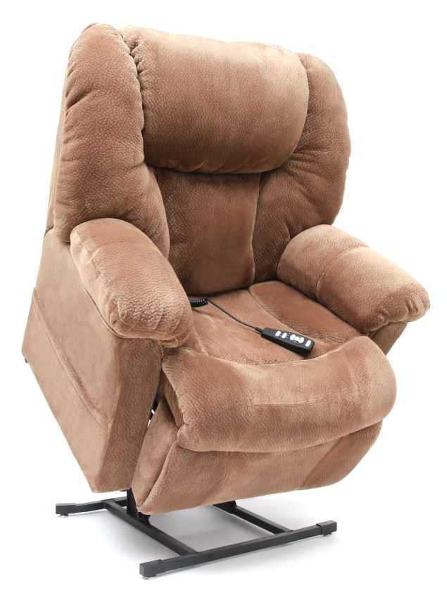

LC-503 CAMEL

