Infinite Position Chaise Lounger
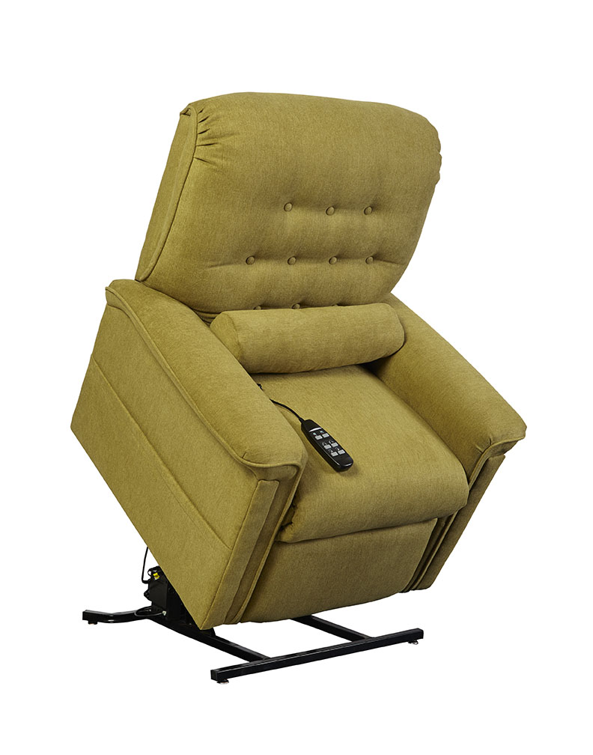

HUDSON
Hudson Features and Benefits
Infinite Position Chaise Lounger

- Infinite-position, all electric lift and recline
- Furniture grade hardwood/plywood construction
- Heavy-duty steel lift mechanism
- 325 lbs maximum weight capacity
- Chaise pad
- Dual motors
- Integrated emergency battery backup
- Warranty: 1 year parts and service and lifetime on lift frame

Weight Capacity: 325 lbs
Seat to Floor Height: 20”
Seat Depth: 20”
Seat Width: 20”
Top of Back to Seat: 24.5”
Overall Chair Width: 35”

Fabric Options (Mona):
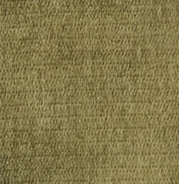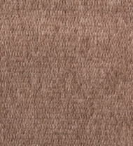
Lavender Kiwi Marmor Nougat

