Loveseat Recliner
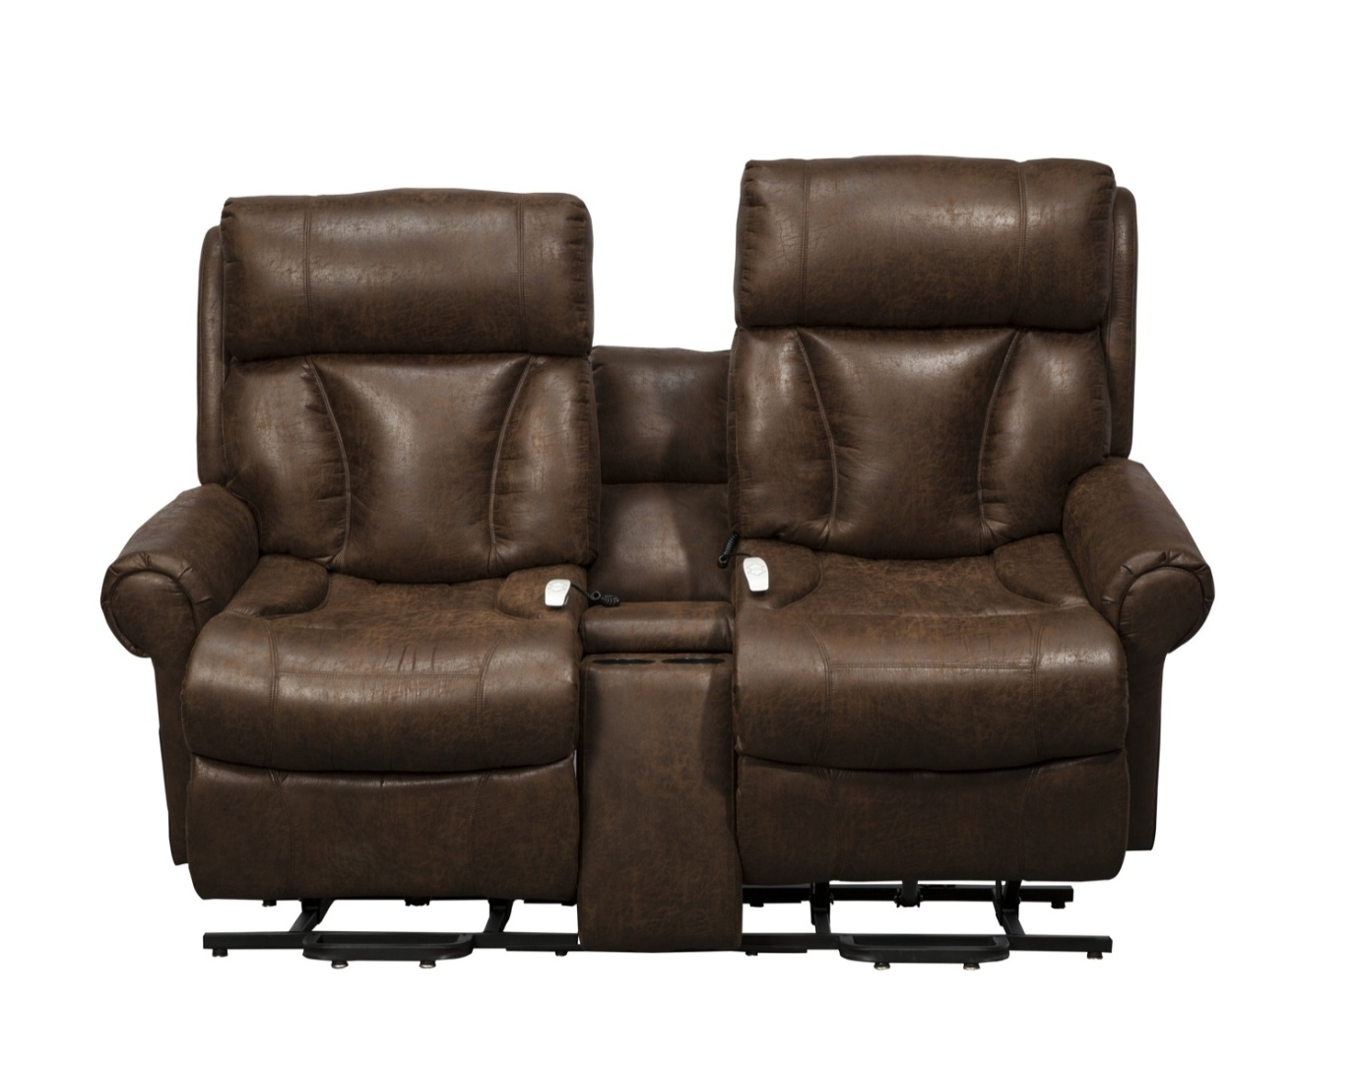

AS-9002

FEATURES AND BENEFITS
3-Position Recline/Lift Loveseat
Double recline/lift console loveseat
Each side of the loveseat is a 3-position power recline with lift option
Unit is a wall hugger, needs to be placed only 8 inches away from the wall
Each side has a 375lb maximum weight capacity
Side pockets and console pocket storage
Chaise pad seat construction
Warranty: 1 year parts and service and lifetime on lift frame
Specifications per side:
Weight capacity: 375 lbs each side
Seat Width: 20”
Seat Depth: 20”
Seat to Floor Height: 19”
Seat Back Height: 27”
Overall Width: 35”
Overall Height: 46”
Recommended User Height: 5’4”-6’0”

Fabric Options:
Palance Tobacco Terry Buff

