3-Position Chaise Lounger

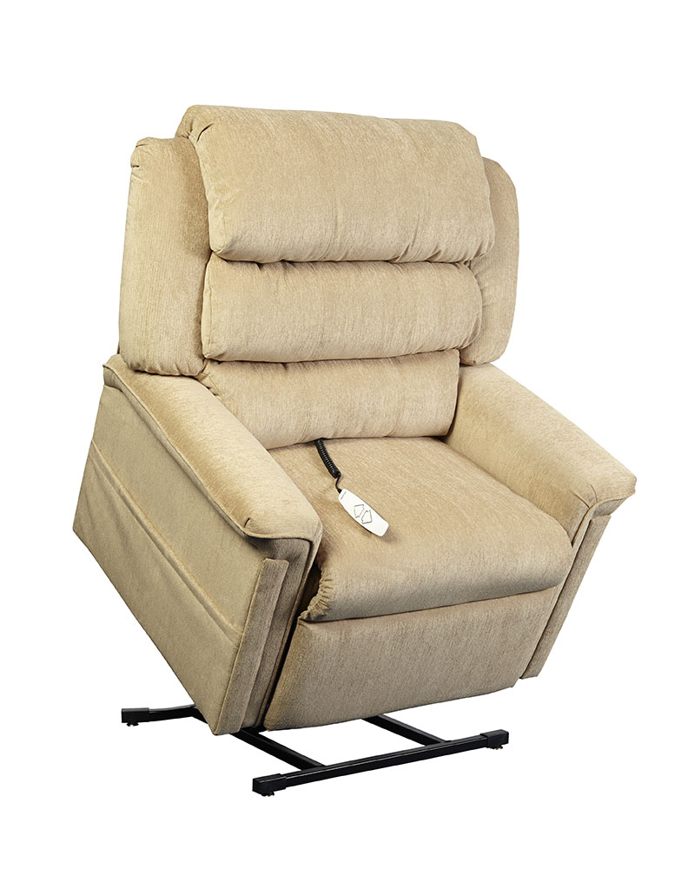
CARSON
Carson Feature and Benefits
3-Position Reclining Lift Chair

- Three-position, all electric lift and recline
- Furniture grade hardwood/plywood construction
- Heavy-duty steel lift mechanism
- 375 lb maximum weight capacity
- Integrated emergency battery backup
- Pocket coil seating
- Convenient pocket on both sides of chair to store magazines, newspapers, or a remote control
- Warranty: 1 year parts and service and lifetime on lift frame
Weight Capacity: 375 lbs
Seat to Floor Height: 19”
Seat Depth: 19”
Seat Width: 24”
Top of Back to Seat: 23.5”
Overall Chair Width: 39”
Overall Chair Weight: 118 lbs

Fabric Options (Atlas):

Earth Camel Slate

