BURTON
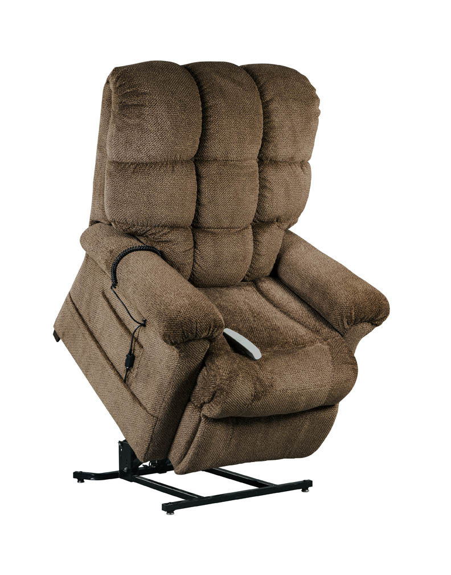

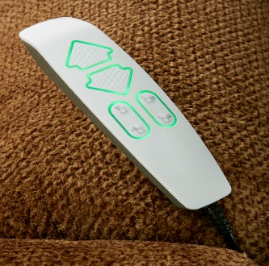

Burton Features and Benefits
Infinite Position Reclining Lift Chair

- Comes standard with a footrest extension
- Great new USB wand with easier usage
- 3 great colors of Angus fabric to match your home décor
- Ultimate in comfort with coil seating
- 375lb weight capacity
- Infinite position, including Trendelenburg position
- Convenient pockets on both sides of the chair for storage

Weight Capacity: 375 lbs
Seat to Floor Height: 20”
Seat Depth: 25”
Seat Width: 20”
Top of Back to Seat: 26.5”
Overall Chair Width: 38”

Fabric Options- Angus

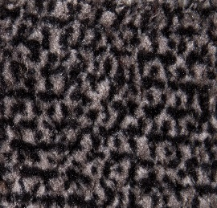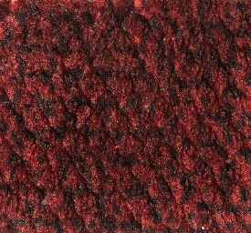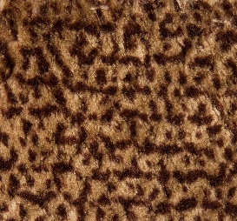
Cobblestone Cranapple Nutmeg

