May 20, 2014

Memo

To: Mega Motion-E-Commerce Accounts

From: Dennis Valkanoff

Re: Additional Chairs for e-commerce

We at Mega Motion want to thank you for a great first 5 months of the year. Our overall business is up 26%. Our furniture retail business is up over 150%.

As we have cleaned out the inventory of the old “Mega” it is time to offer to our e-commerce partners some new and exciting products.

Contact Lora for what you need to set up if you wish to offer these chairs.

New Chairs-

“Elk”

The “Elk” chair is a Made in USA chair. Price of the chair, freight included to the customer’s front door, $475.00-MAP is $799
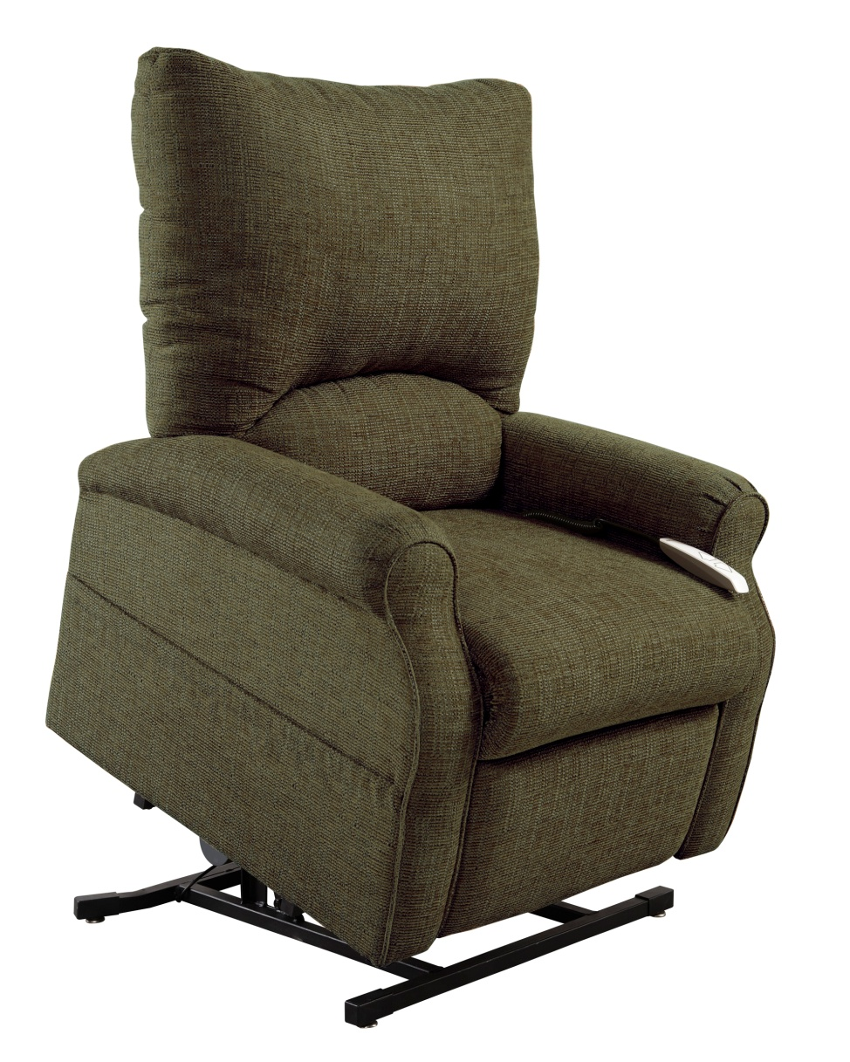

“Torch”

You have asked for a bigger seat, the “Torch” offers this for you. Done is a great polyester knit, this chair has a wide and comfortable back and a “bucket” seat for great comfort. This chair has great sewing detail. Cost of the chair to the customer’s front door, $525, MAP is $899.

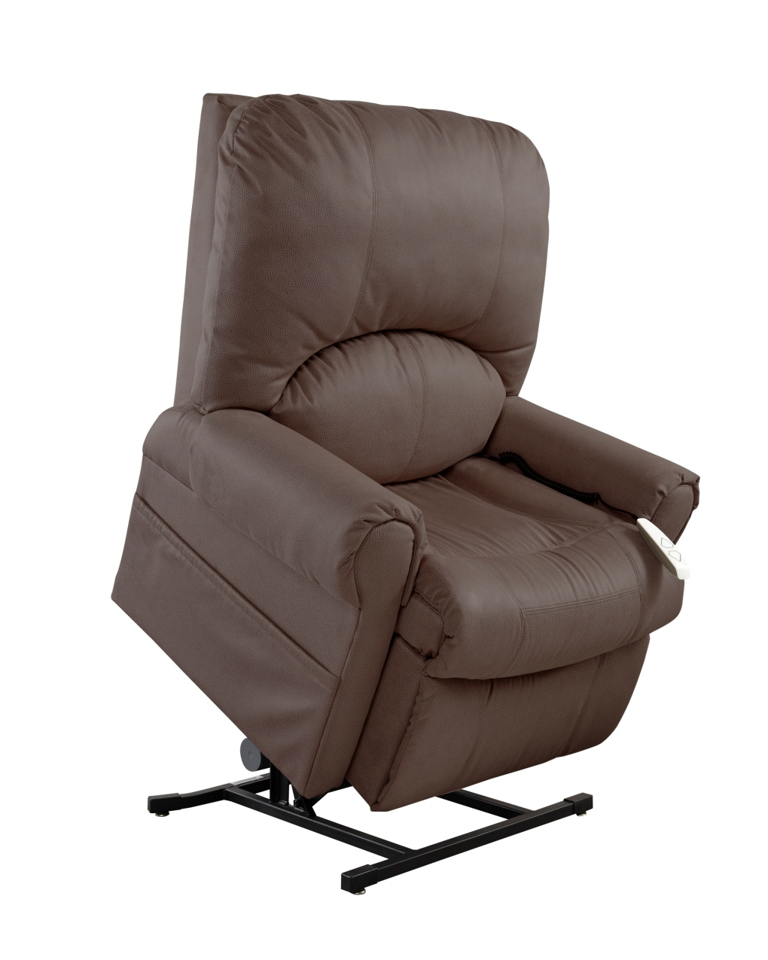

“Superior”

A new and updated chair that can lift 500#. Dual Motor chair. Cost delivered to the customer’s front door, $725. MAP is $1299

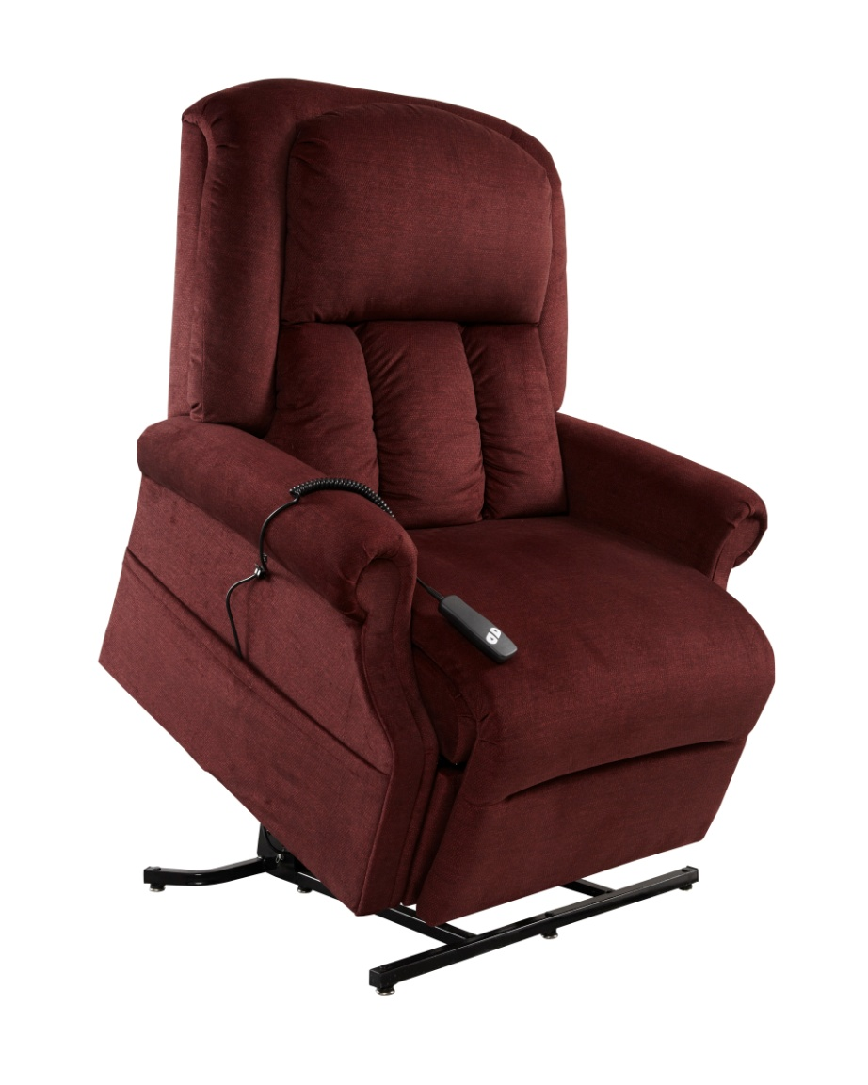

As we move forward, we are looking at some other domestic options, these can be chairs built and shipped within 10 days. If you would like to have this option, please give me a call.

Dennis Valkanoff
919-208-5949

